**SPH3U 9.5 The Doppler Effect**

1. **The Doppler Effect**

|  |  |
| --- | --- |
| The Doppler Effect: |  |
| equation |  |
| vsource |  |

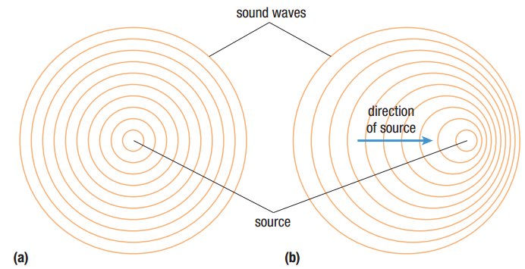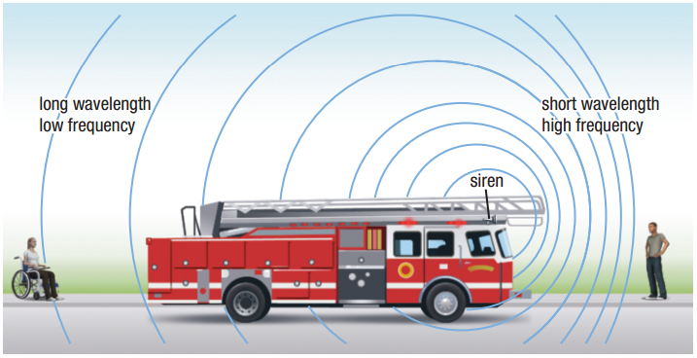

Suppose a fire truck is moving toward a stationary observer at 25.0 m/s. The frequency of the siren on the fire truck is 800.0 Hz. Calculate (a) the frequency detected by the observer as the fire truck approaches and (b) the frequency detected by the observer after the truck passes by. The speed of sound in this case is 342 m/s.

**Homework:** page 435: #4-5